**E- COMMERCE PLATFORM**

**User Interface Design**



**A Group Project Submitted for Undergraduate DBMS Lab (BCA481)**

**Submitted By:**

AHANYA MARIAM POKKAMTHANAM, 2241107

ANTONY CHANDY DOUGLAS, 2241117

RUCHIT DHANUKA, 2241150

**Department of Computer Science**

**CHRIST (Deemed to be University)**

**Bengaluru,India**

**INTRODUCTION**

HomeHive aims to become a leading online marketplace for household products by offering unique features like cryptocurrency payments, shared carts, and group buying, while maintaining the familiar functionalities of established e-commerce platforms.

In this report we delve into the user interface (UI) design of HOMEHIVE, an online furniture platform. From the Home Page to the Payments module, we’ll analyse the visual and navigational elements that shape the user experiences. This exploration aims to unravel how each component aims to unravel how each component contributes to an engaging and efficient digital shopping journey.

1.Home Page

The digital storefront of HOMEHIVE is crafted to present a harmonious blend of aesthetics and functionality. The Home Page serves as the initial point of interaction, strategically featuring curated highlights and user-friendly elements.

2.Categories and Subcategories

Effective categorization is explored, examining the logic and user-friendliness behind the organization of furniture into categories and subcategories.

3. Sign-Up Page

The Sign-Up Page is scrutinized for simplicity, security measures, and efficiency in capturing user information to encourage active engagement.

4. Profile Module

The profile module adds a personal touch, offering features such as account management, payment details, orders and return history.

5. Cart Module

Efficiency in the shopping process is key; the Cart module is crafted for user-friendliness, easy item management, clear pricing details. It also includes the feature of shared carts that allow the user to share cart details to other users.

6.Payments Module

The journey concludes with the payments Module, with various payment options that include cash on delivery, credit/debit card, upi, cryptocurrency ect.

7.Sub Profile

The Sub profile page within HOMEHIVE’S Ui design provides a comprehensive glimpse into the key aspects of the platform. It elegantly showcases the profiles of teams members and gives details about the HomeHive as well the means to contact.

**USER LOGIN AND SIGNUP**

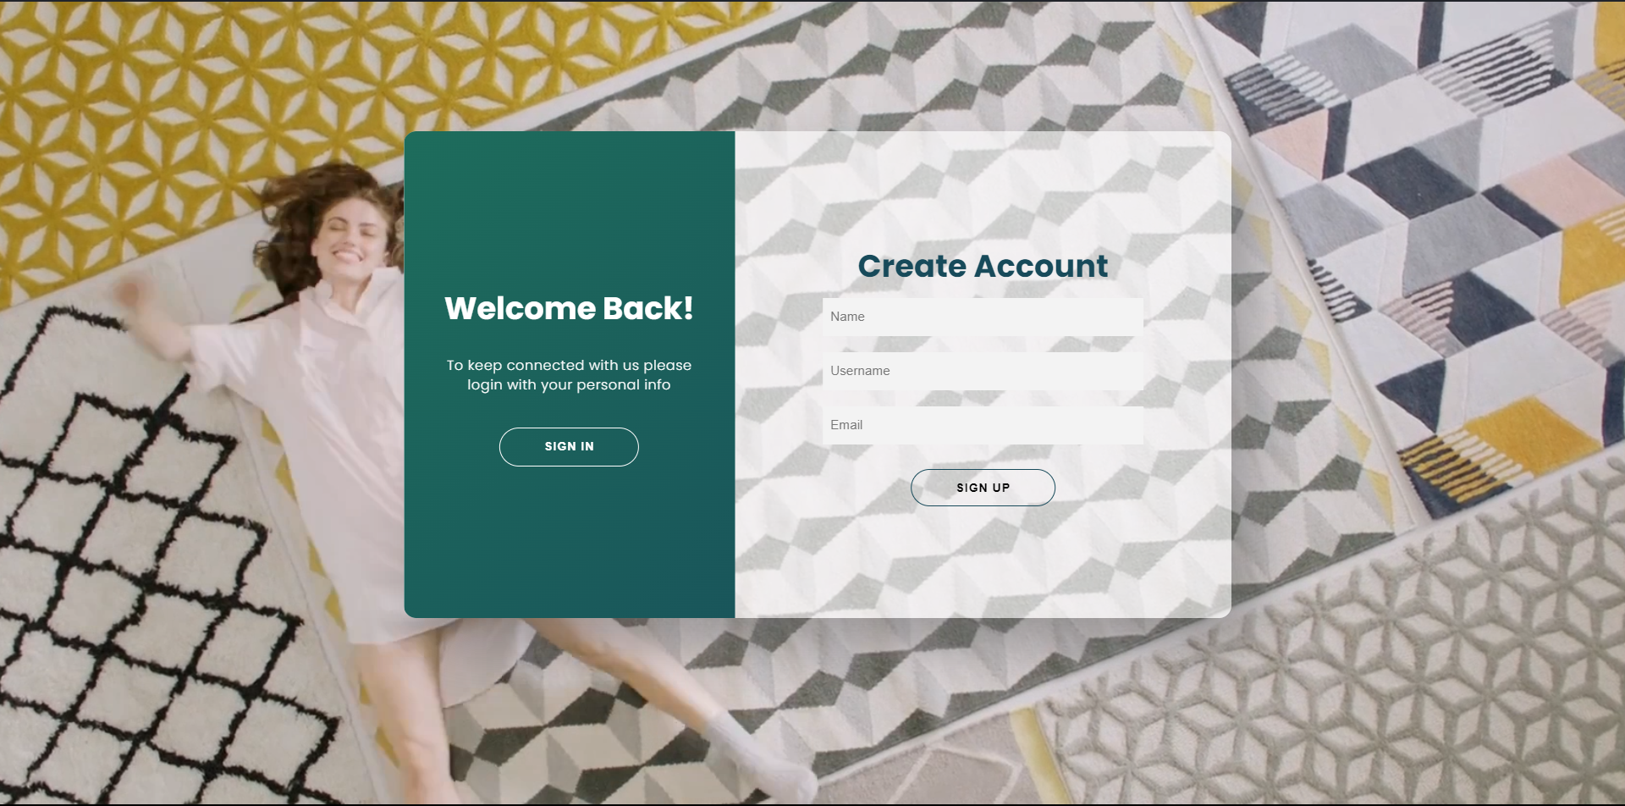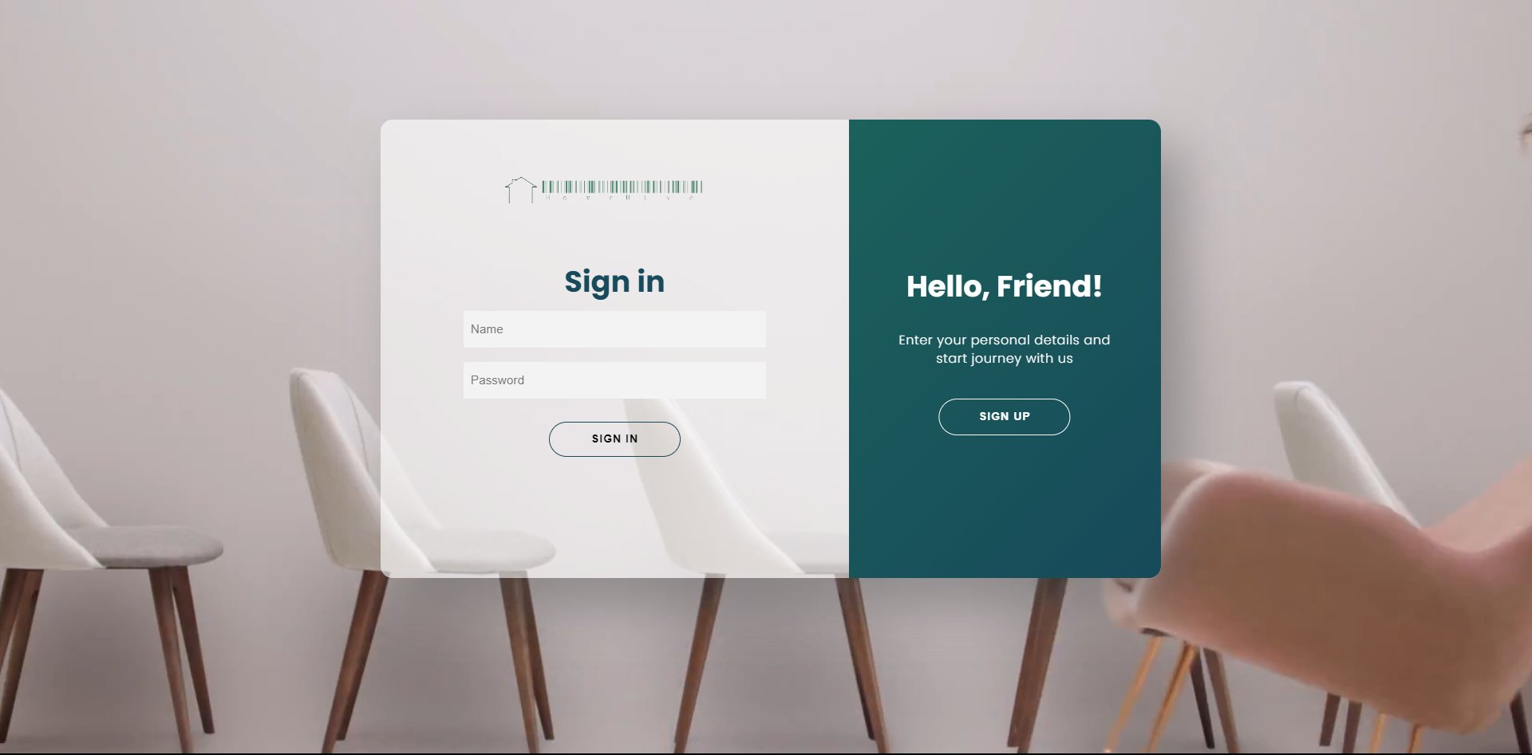

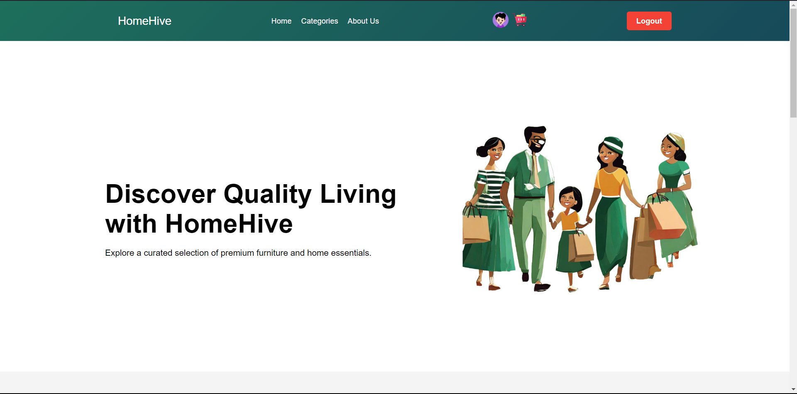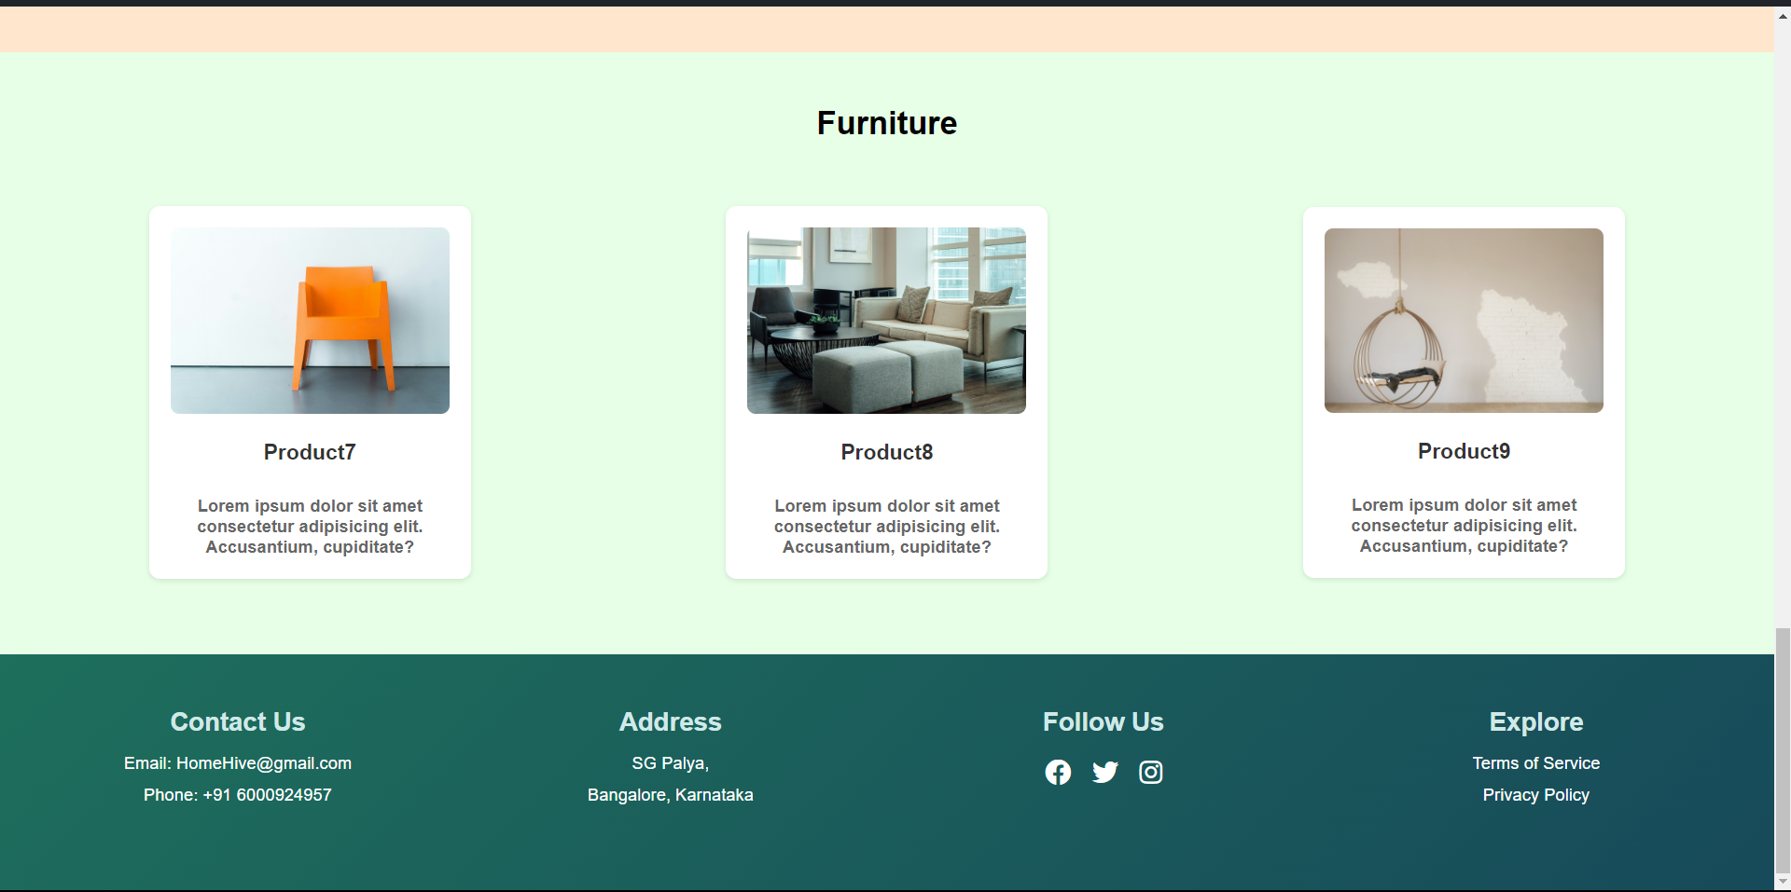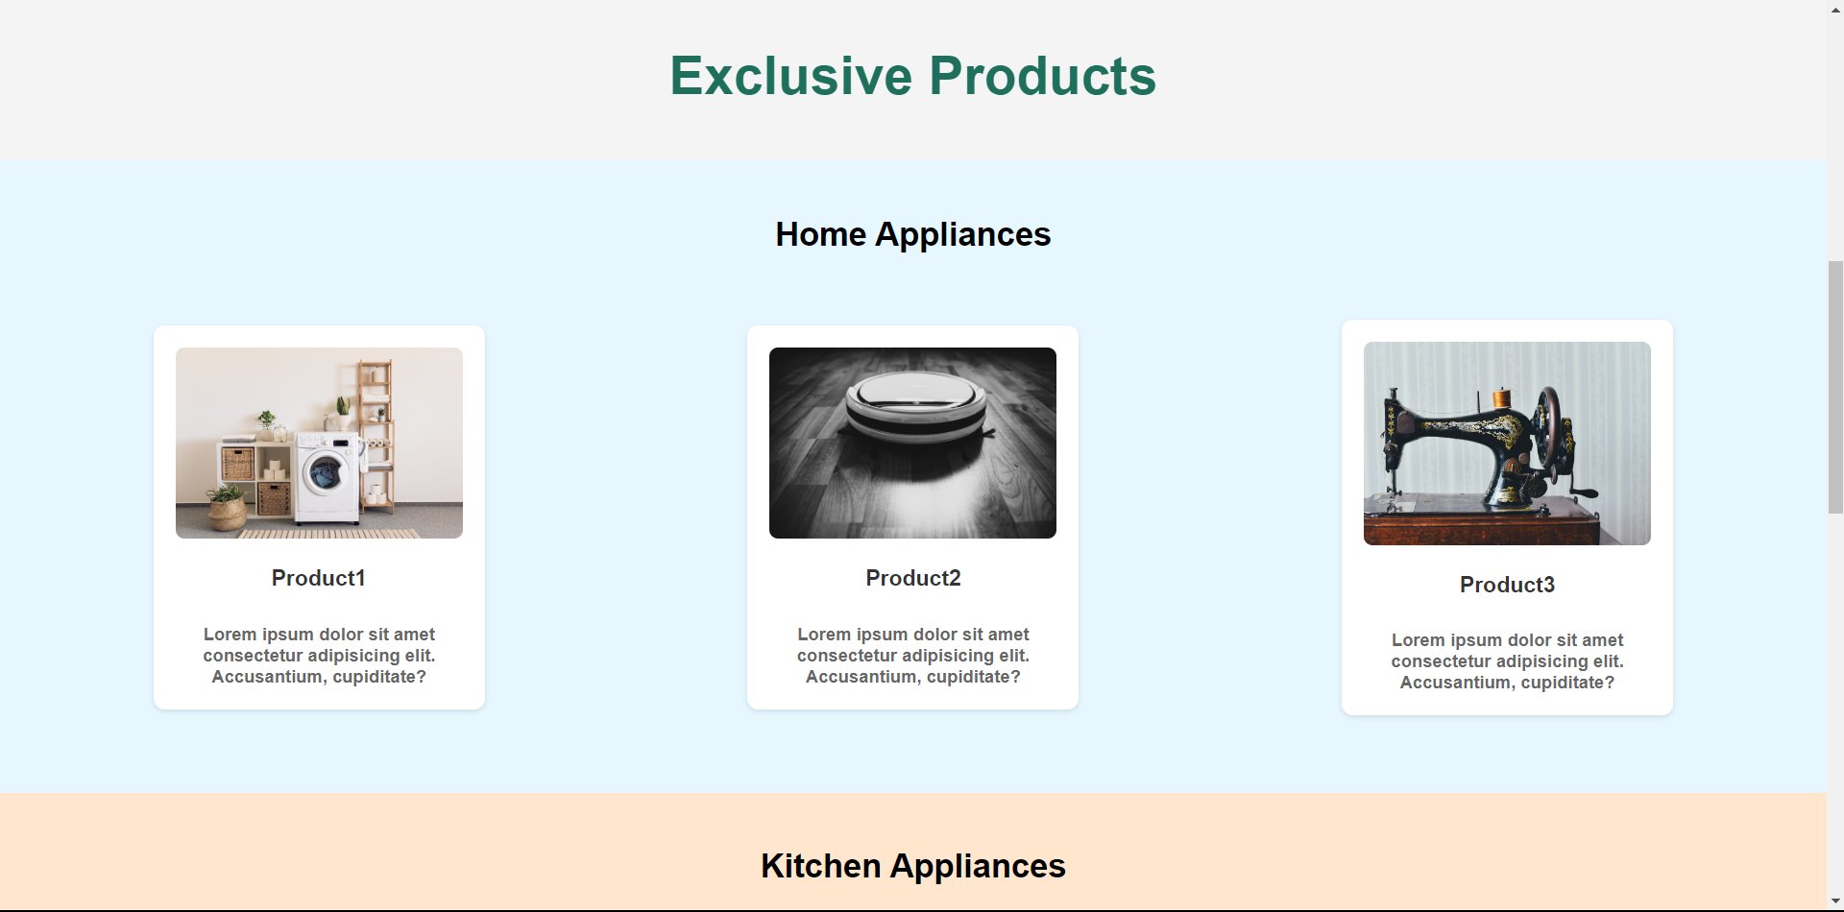**HOME PAGE**

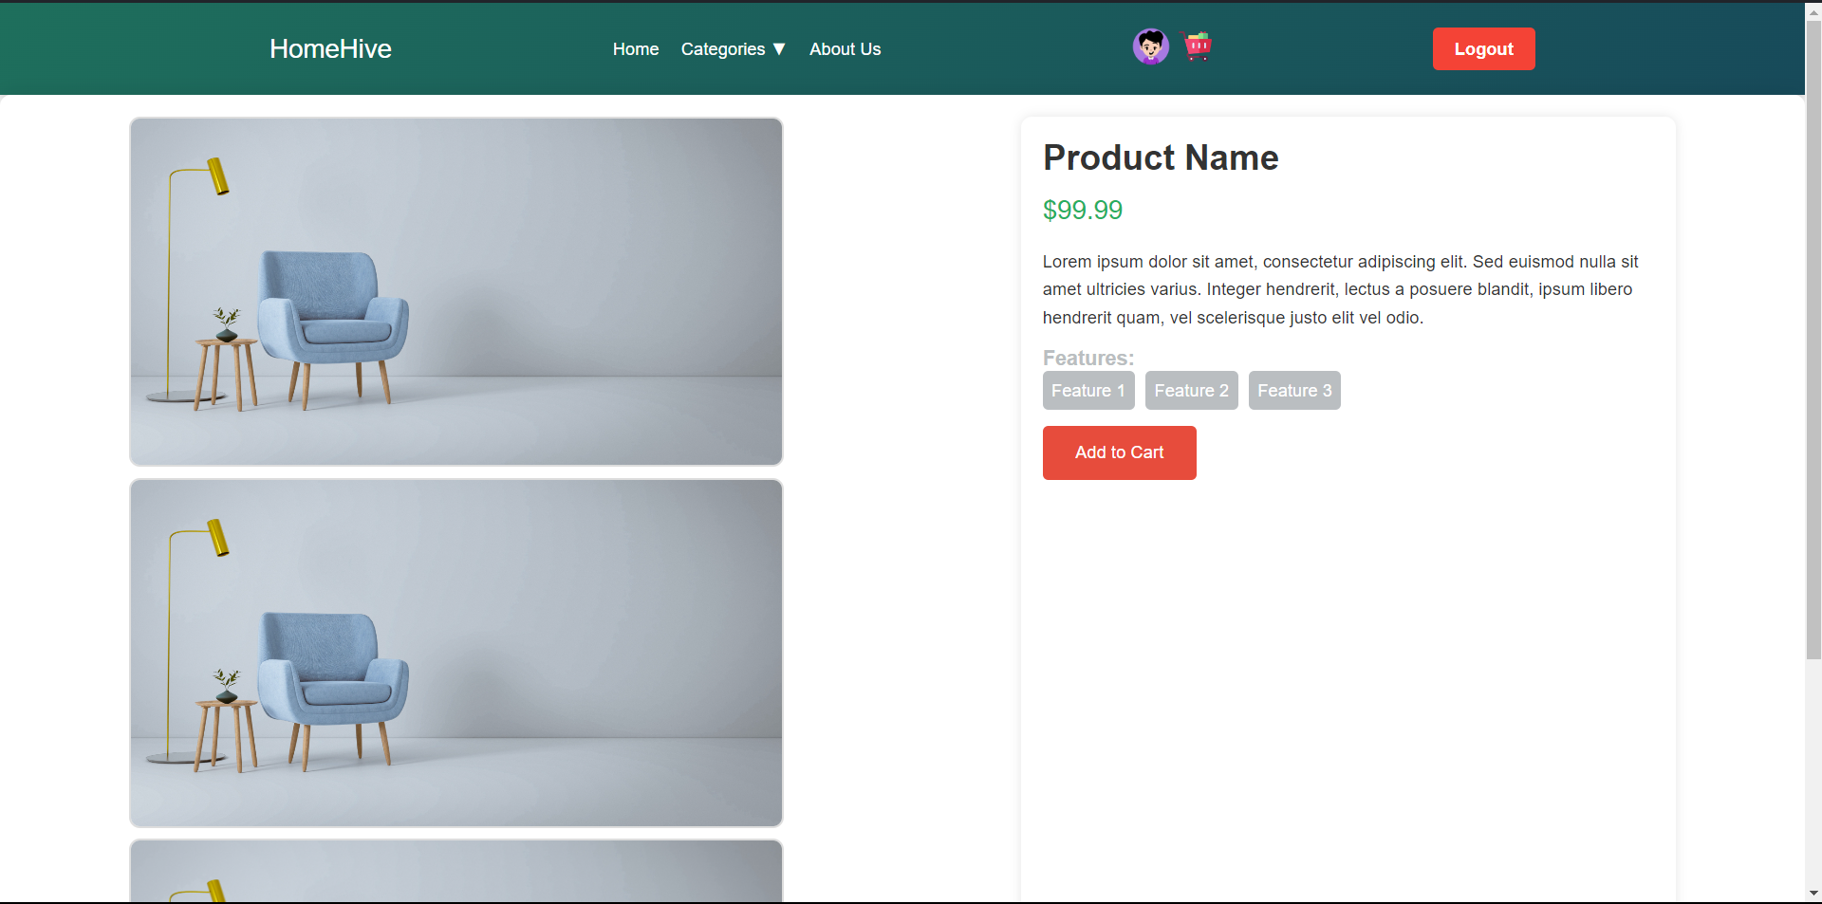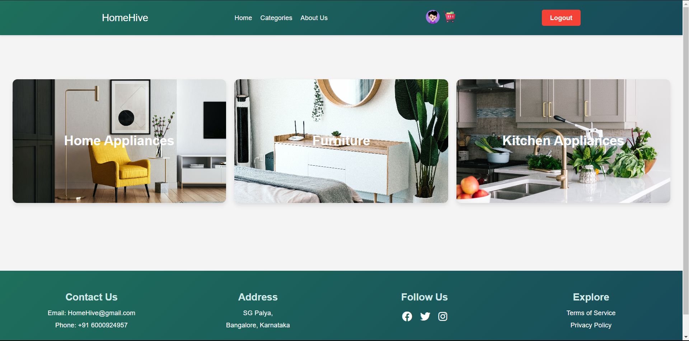**CATEGORIES**

**SUB CATEGORIES**

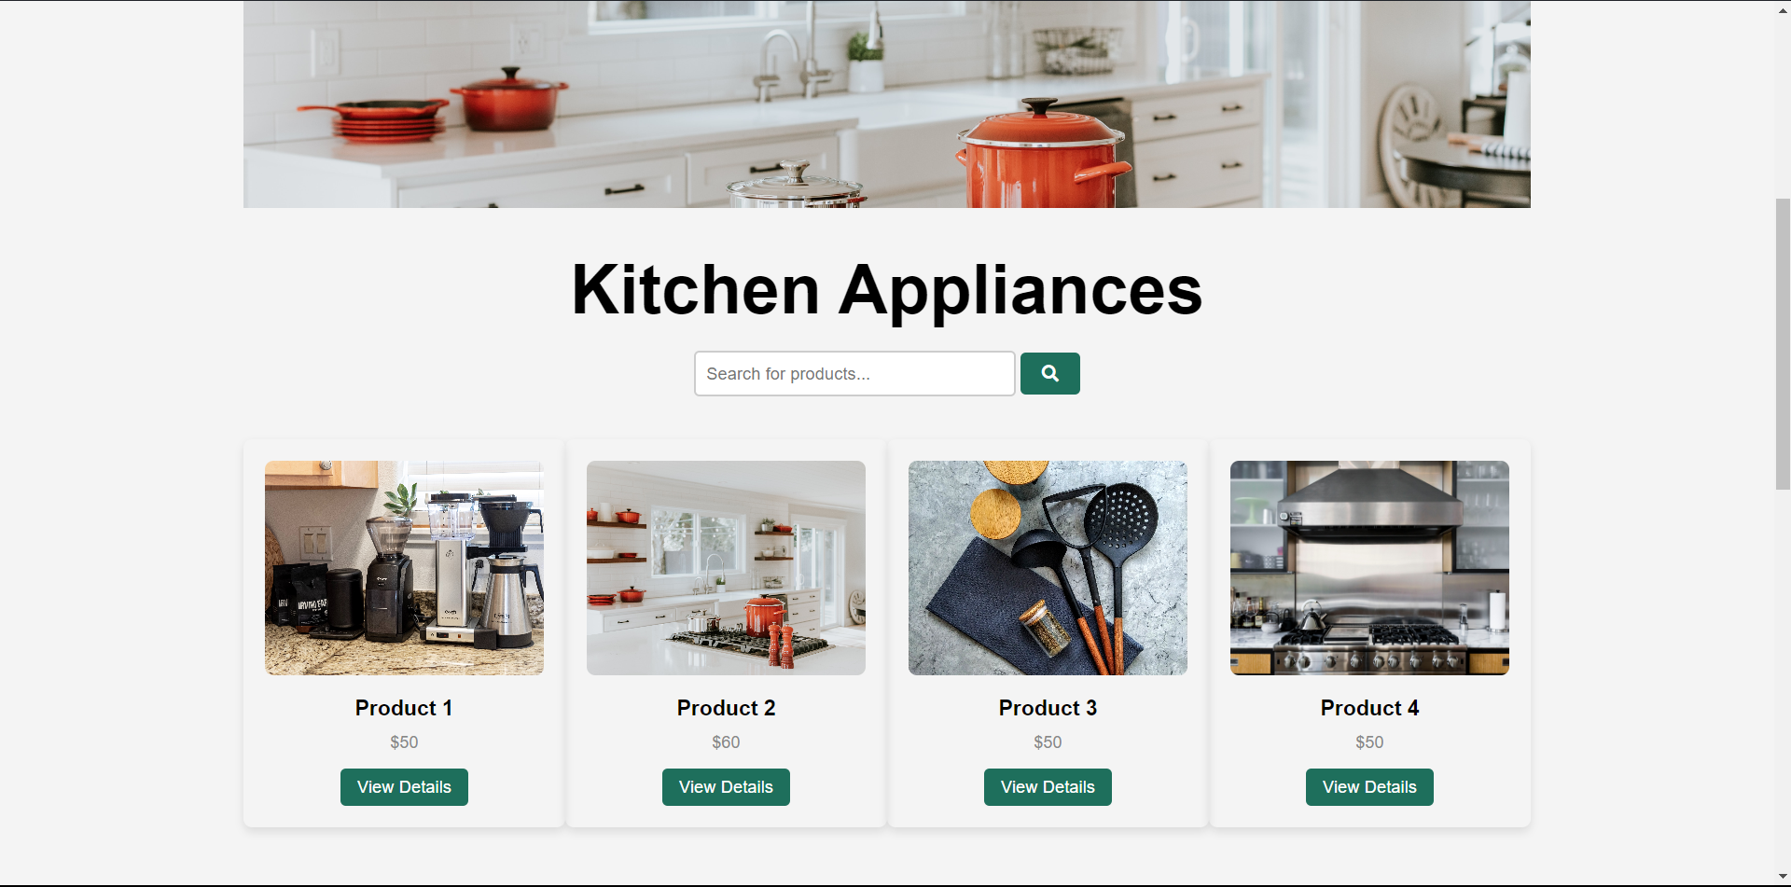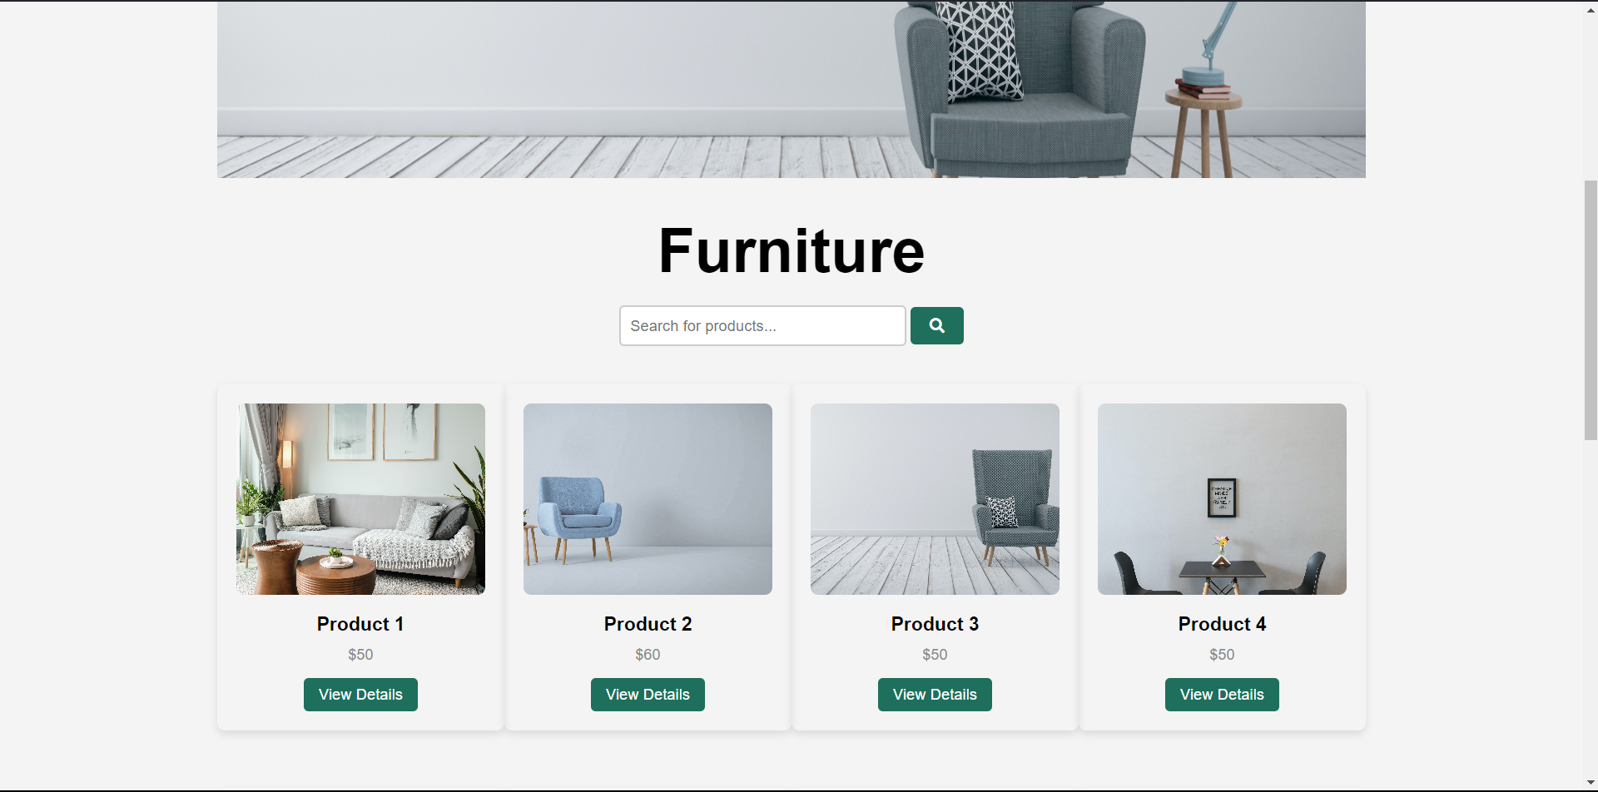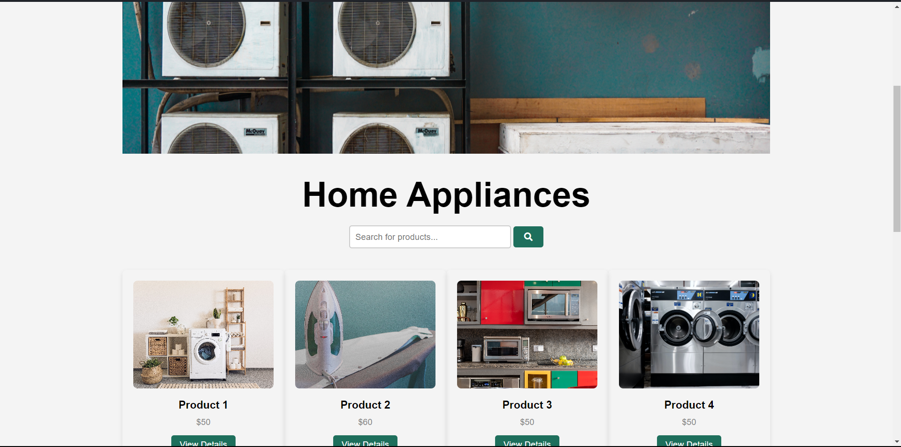

**PROFILE**

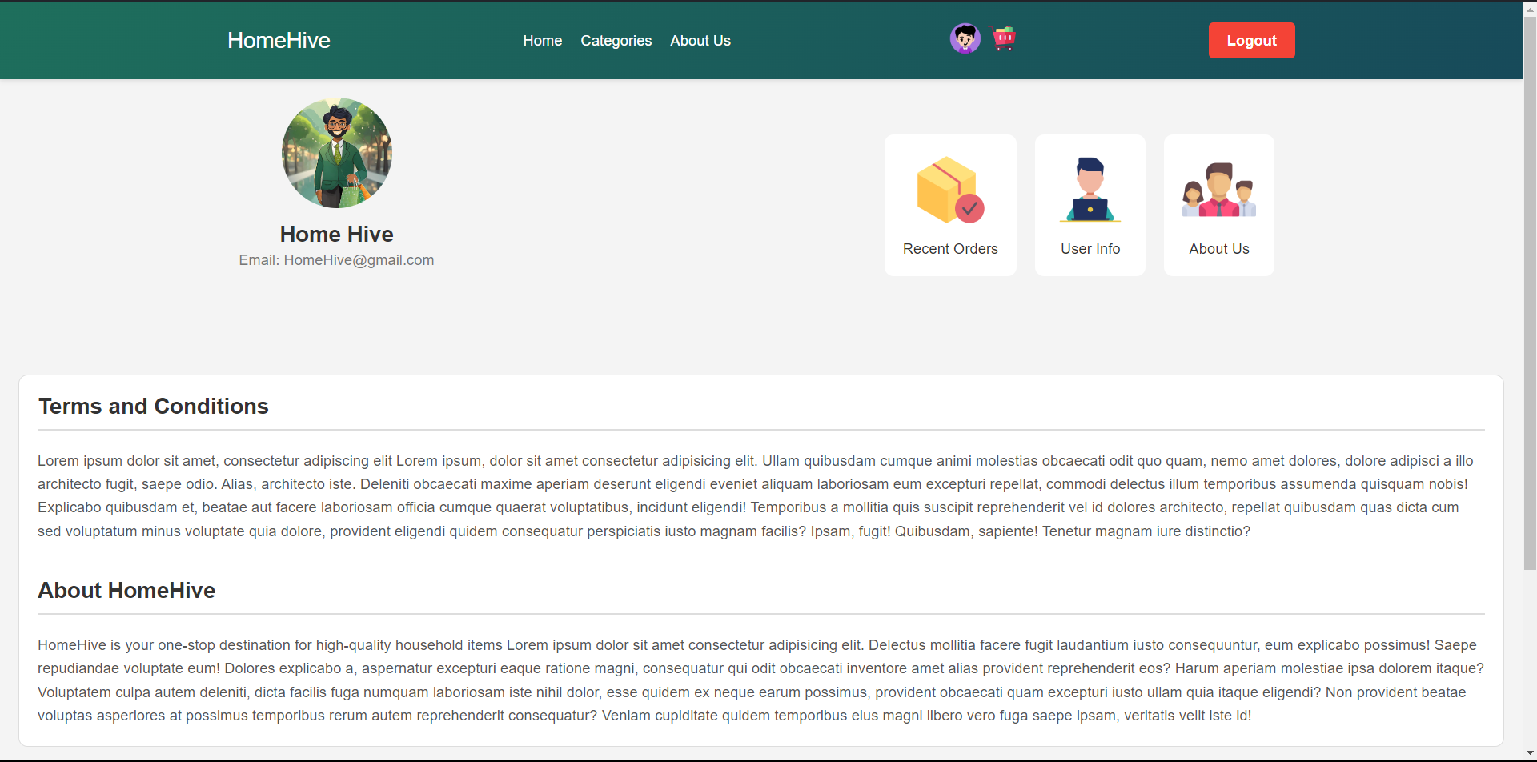

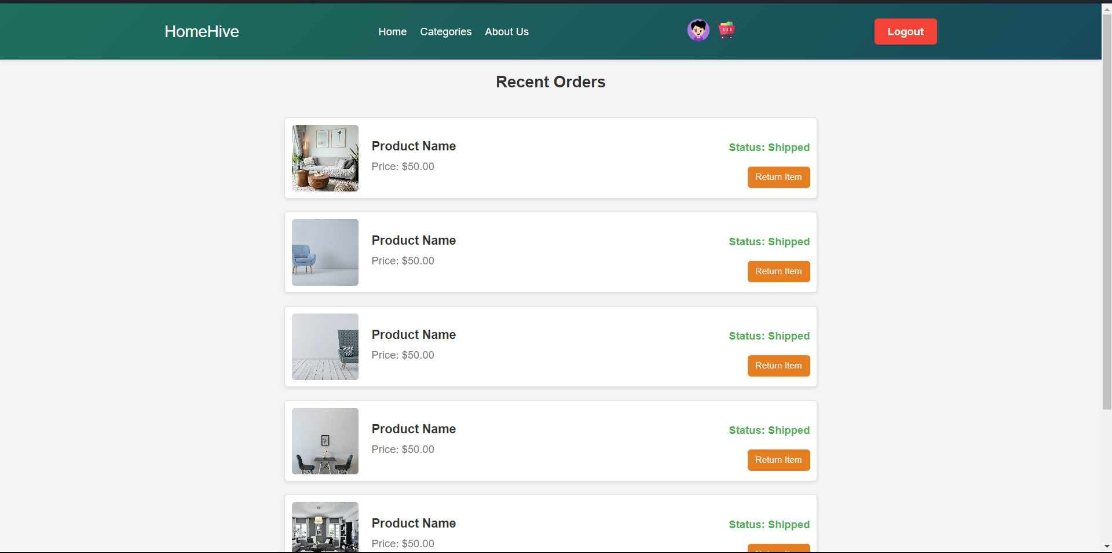

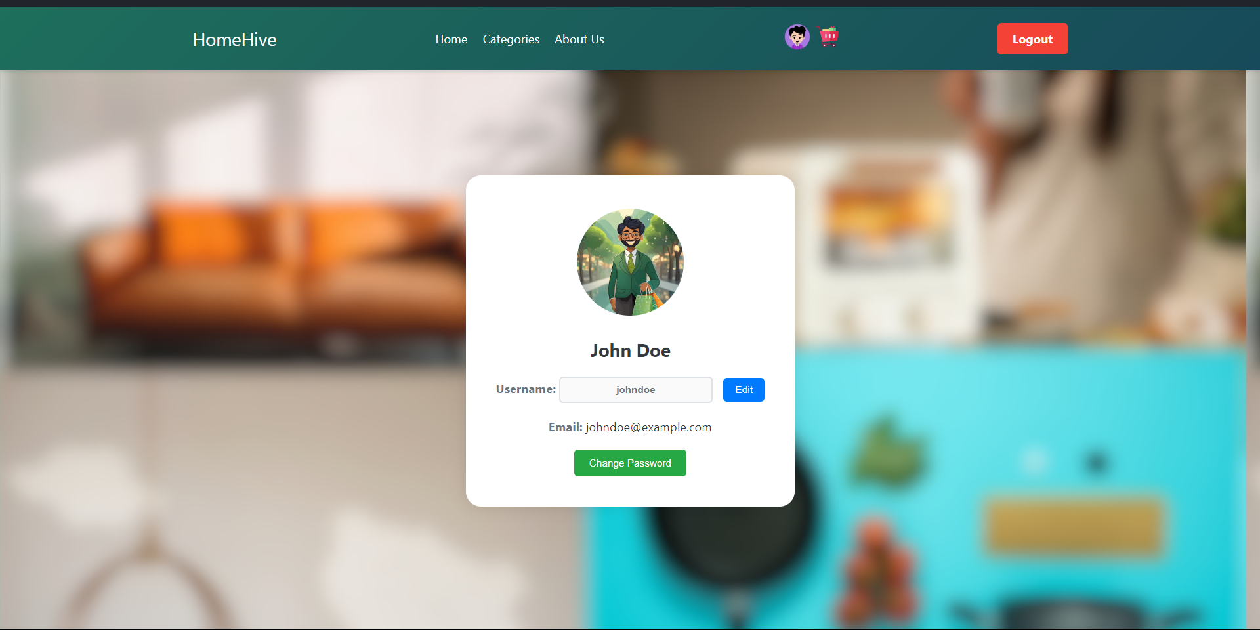

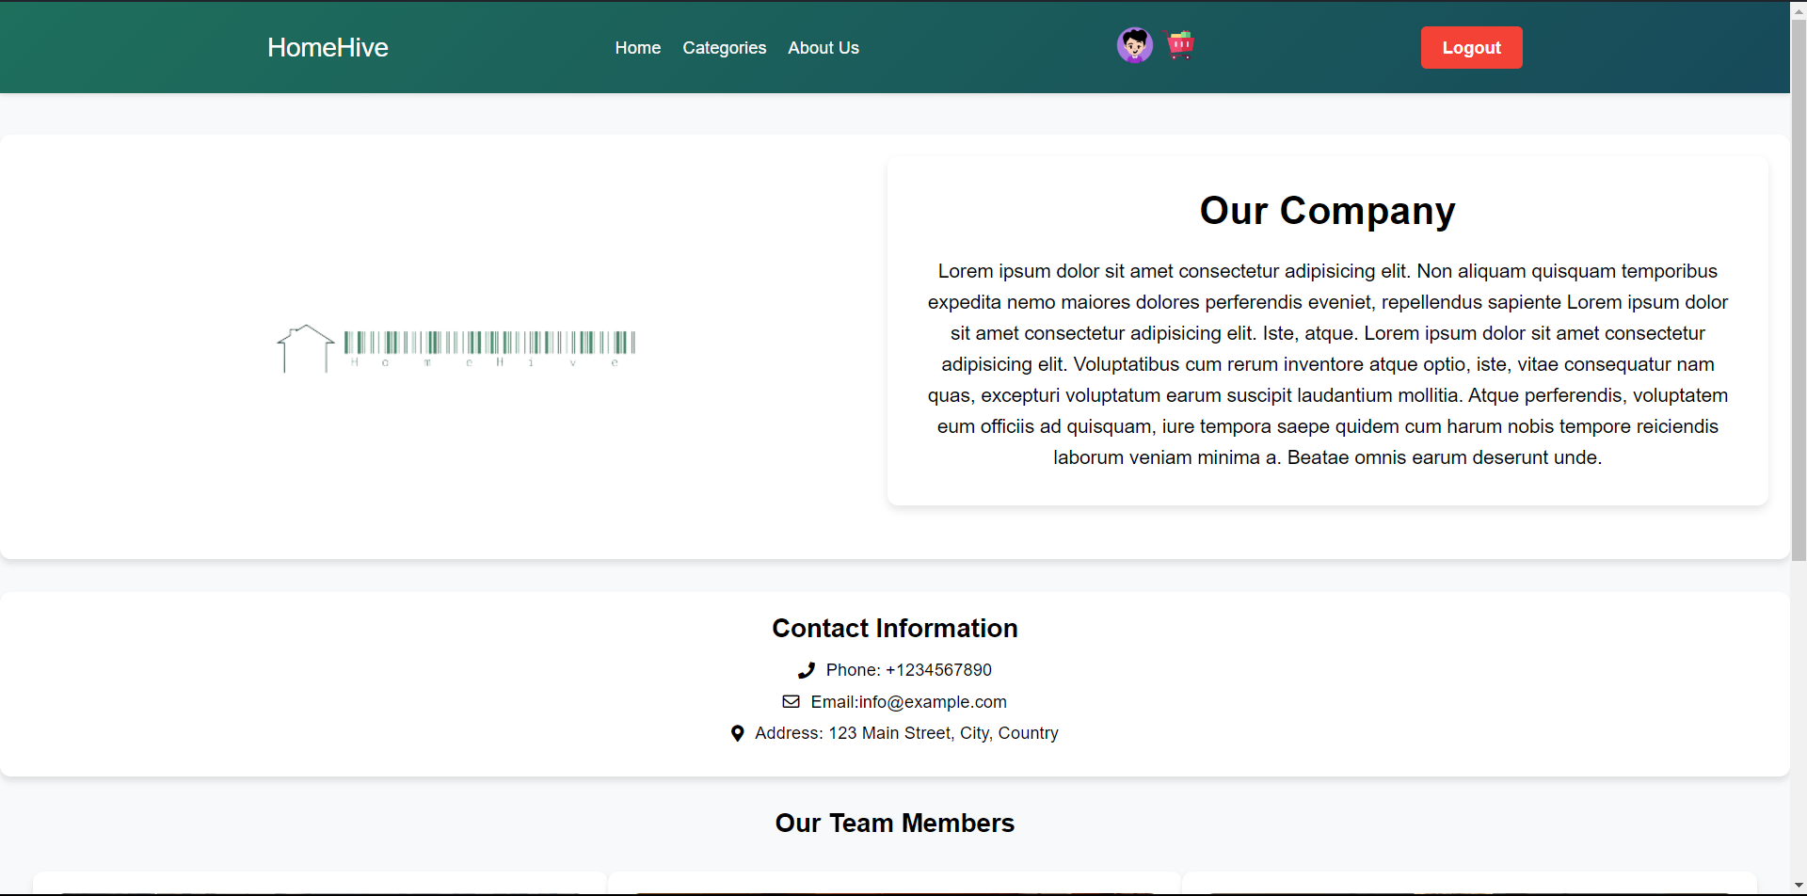**SUB PROFILE**

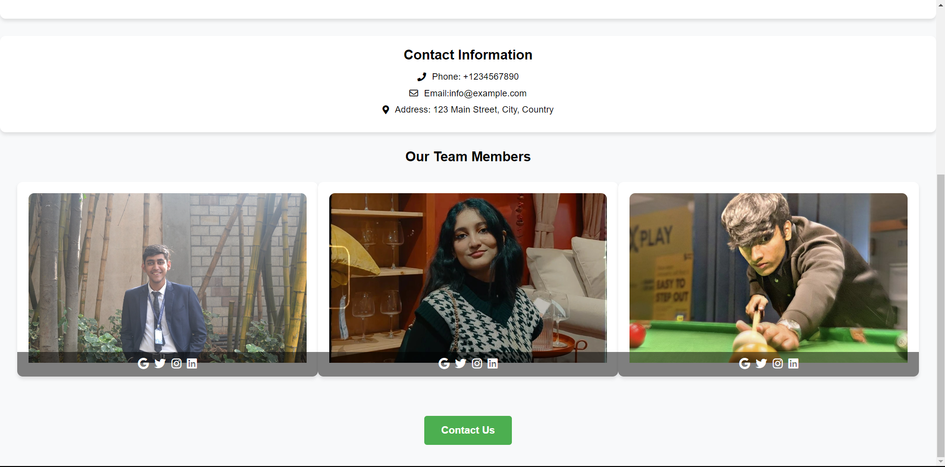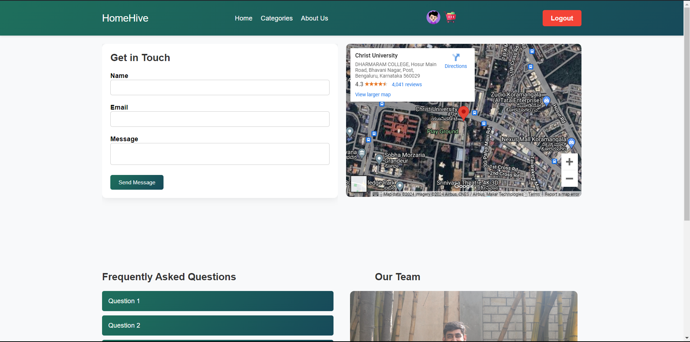

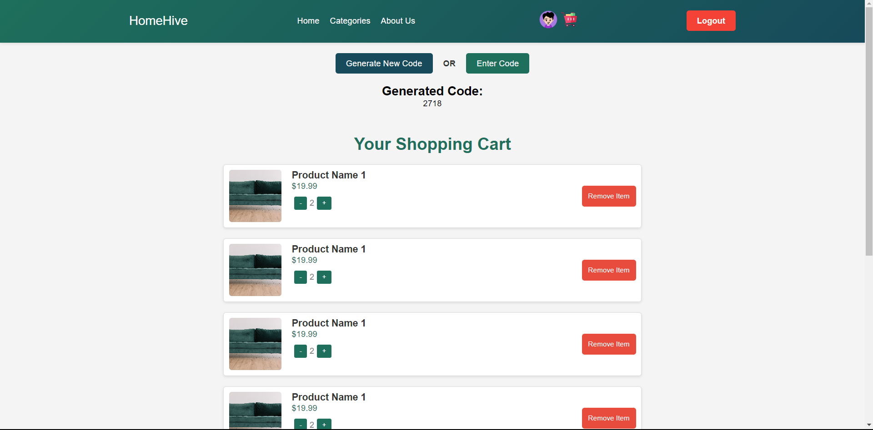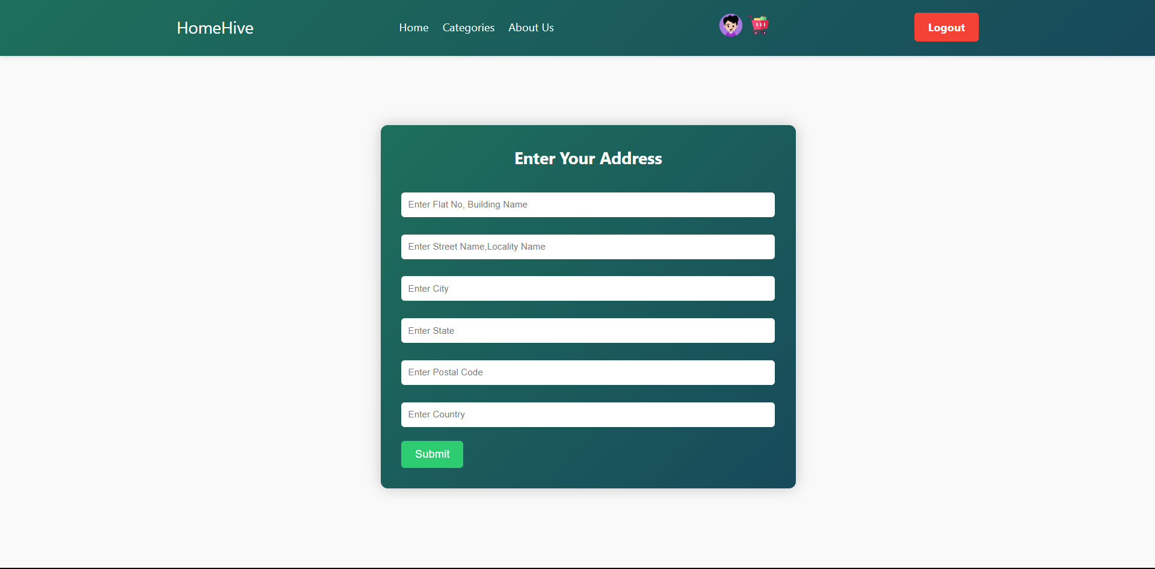**CART**

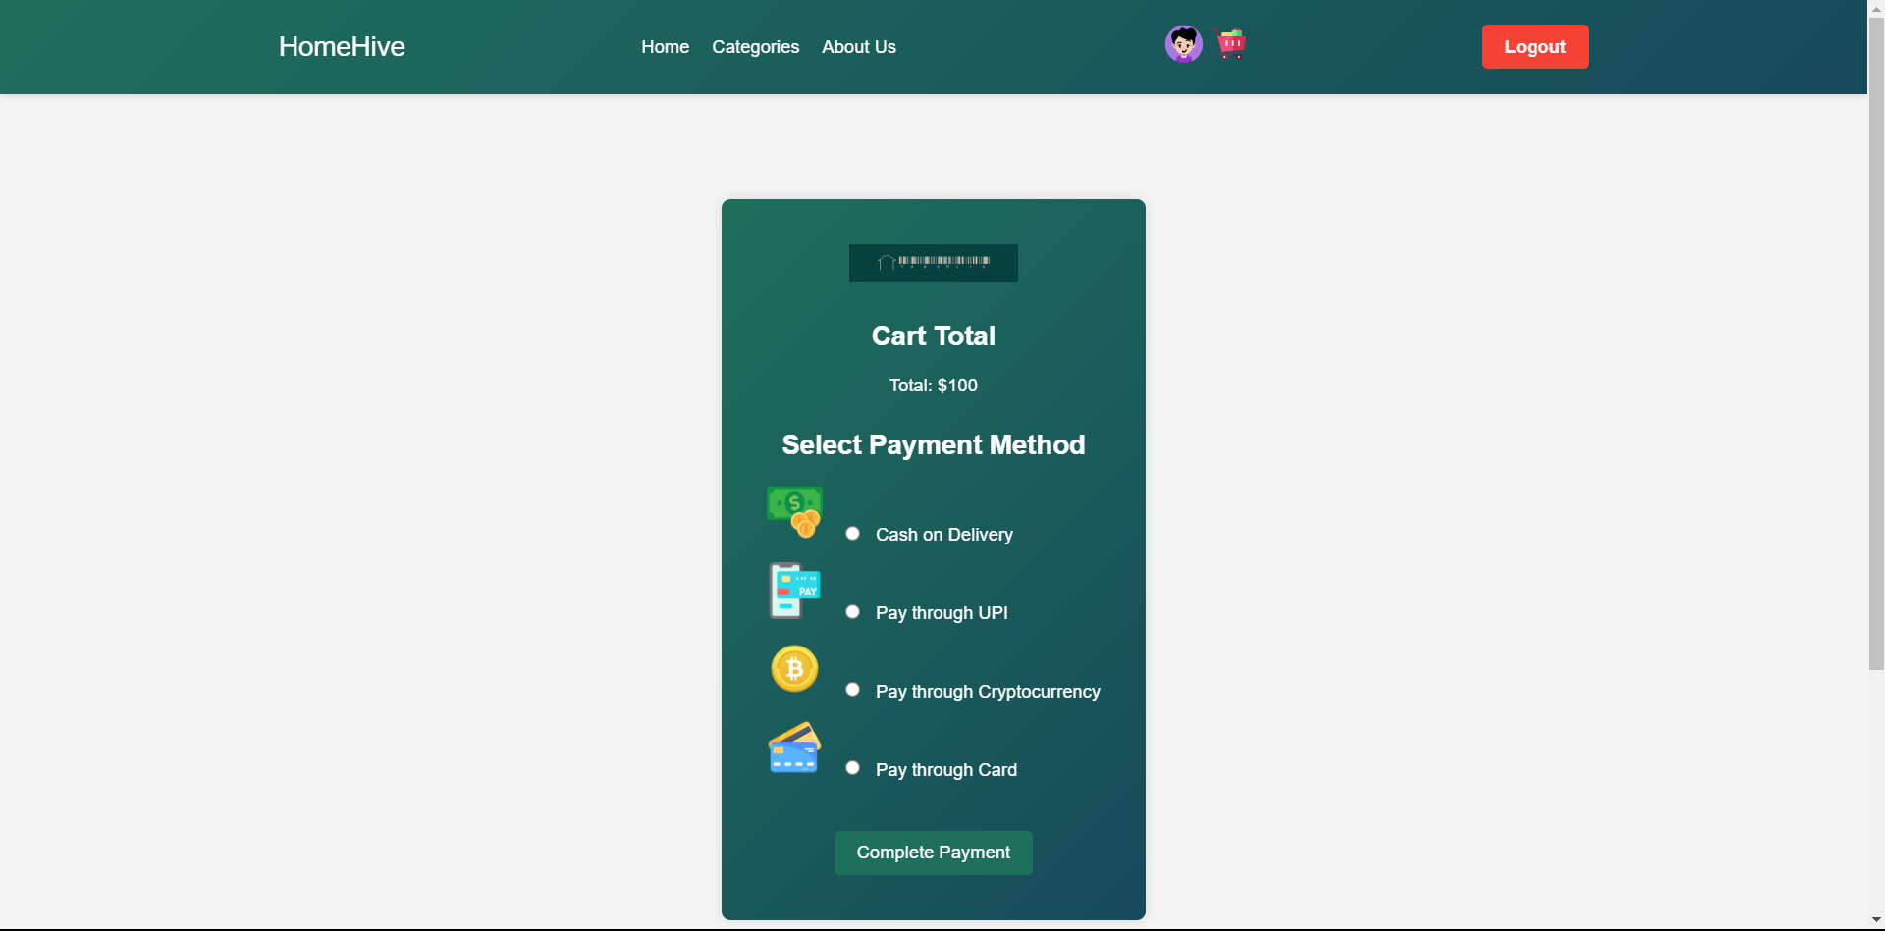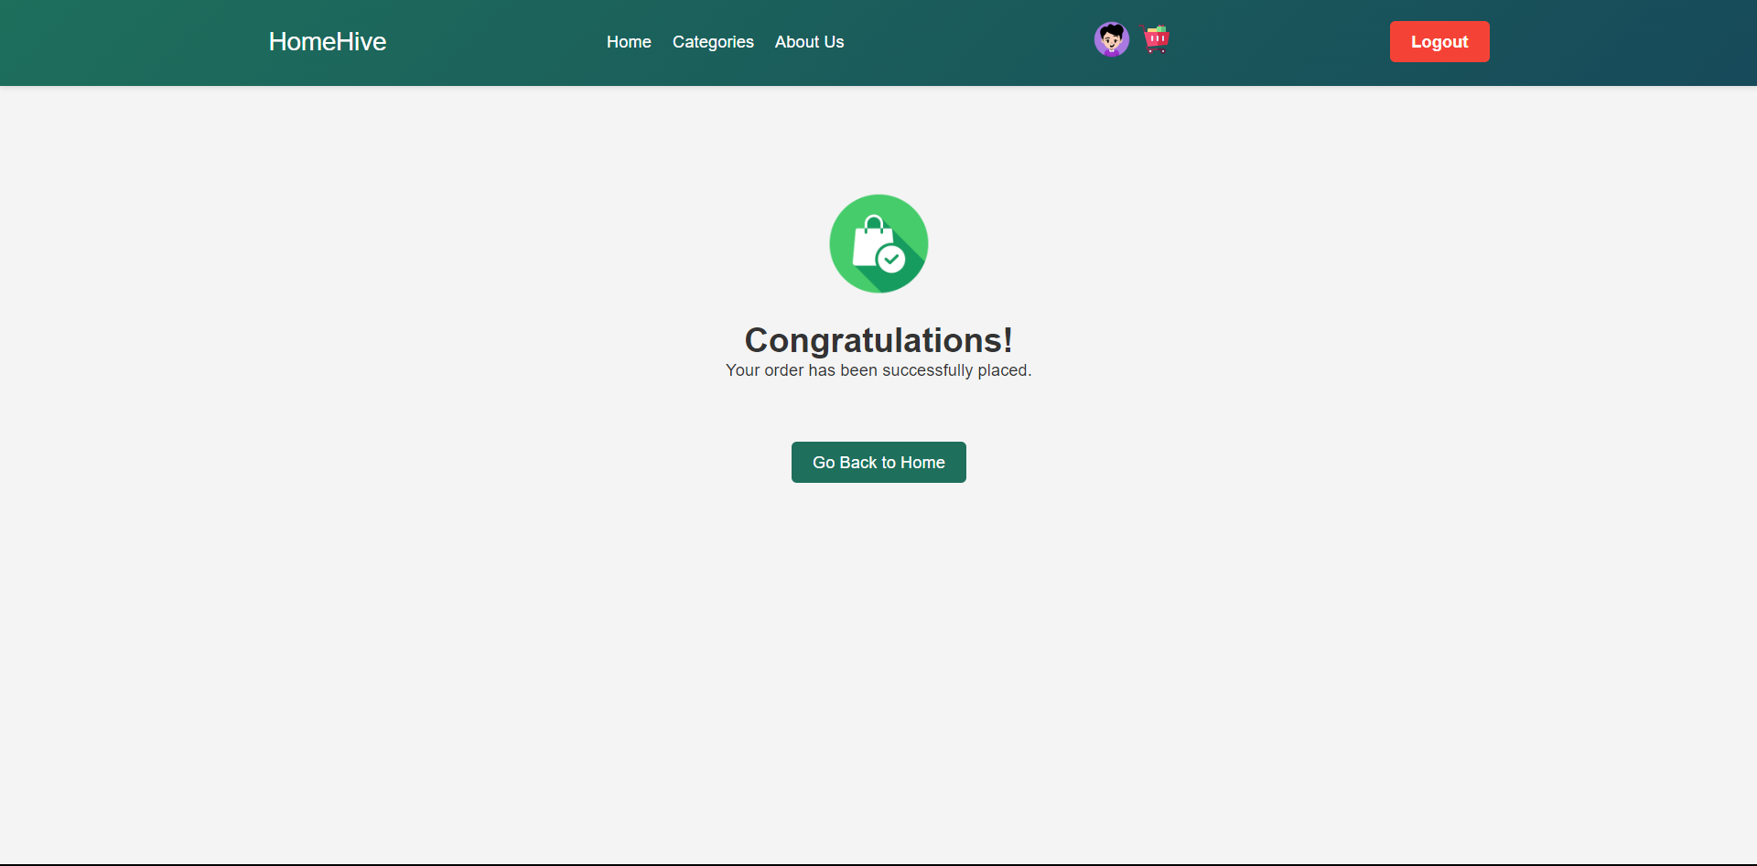**PAYMENT AND ORDER**